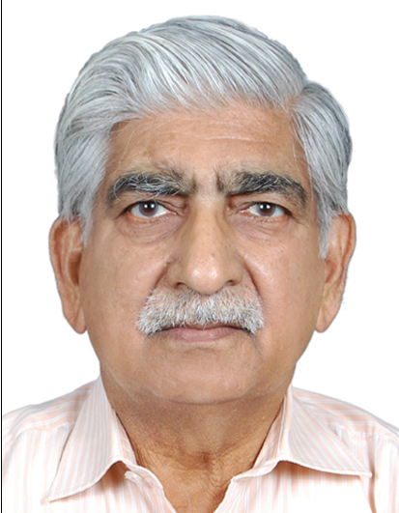

Name: DR R. D. MUKHIJA

Designation:
Former Professor & Head, Dept. of Skin, VD & Leprosy, Former Principal,
BRD Medical College,Gorakhpur-273013

Important Achievements:
- Dr R.D. Mukhija did his MBBS from MAMC New Delhi in Dec 1968 and MD from AIIMS New Delhi in Dec 1972, under the guidance of late Prof .K S KANDHARI, late Prof. L K BHUTANI, DR J S PASHRICHA
- He joined as Lecturer at Jhansi in 1973. He was one of the first to start Dermatology Dept. in UP
- From 1975 to 2008, worked at Medical College Gorakhpur
- He has about 35 years of Undergraduate and Postgraduate teaching experience and has trained more than one hundred Postgraduate MD & DVD students at Gorakhpur.
- The Deptt has a busy outdoor, indoor of 50 beds & facilities for research
- He has published over 100 scientific papers in Indian and International Journals.
- He has special interest in Clinical Dermatology and Leprosy.
- He was the President IADVL (UP)
- He was the Chairman, Scientific Committee Dermacon 2010 at Lucknow
- He has been awarded Teacher Par Excellence Award at Dermacon 2011, Gurgaon
- He has been awarded Lifetime Achiecement Award at SAARC AAD International Summer Symposia at St. Petersburg , Russia, 2018
- He has been conferred Inspiring Dermatologists of India award at The Economic Times Doctor’s Day Conclave 2019
- After retirement, he is doing Private Practice with his son who also is a Dermatologist. The clinic has all modern facilities & has latest Lasers

